WRO 2026- Future innovator
  - Junior Category

Merge and Connect

A Robotic System for Social-Awareness Art Creation and Presentation

Team Members:
Advaith Venkatesh
Vedant Candadai
Pranav Rithivik. M
Contents
About the team 3
Summary of Project 4
Problem 5
Robotic Solution 6
Process and Other Ideas 7
How are we Different? 8
Mechanical Solution 9
Digital Solution 11
Use of AI 13
Social Impact 14
For Whom? 16
Importance 17
Application 18
Business Model 19
Sources 21

About the team
The team is made up of Advaith, Vedant, and Pranav. This is a team from Bangalore, Karnataka, India.
Advaith, Vedant and Pranav all go to the same class and share a passion for Robotics. Thus, we decided to register for WRO 2026 together.
Advaith took care of the research and presentation. Vedant took care of coding and training. Pranav took care of the Hardware components and their calibration of the components.

Summary of Project
Project Merge and Connect solves the problem of static gallery displays that fail to bridge cultural and language gaps for modern viewers. By moving beyond traditional frames, this project uses a 3-axis robotic arm and TOF sensors to transform art into an active participant. The robot physically detects a nearby viewer and reorients its canvas to face them, creating a personalised "human" connection that static exhibits lack.
The robotic solution uses Neural Style Transfer (NST) to live-paint digital images in global styles—like Kalamkari or Mughal Miniature—while narrating the history in the viewer’s preferred language. In a real-world museum, this acts as an inclusive educator, making complex art history approachable for students and tourists alike. By physically greeting the audience, the robot ensures that cultural heritage isn't just seen, but experienced.
This project is vital because it proves that industrial robotics can serve as a vessel for culture, not just manufacturing. It preserves ancient traditions through a high-tech lens, ensuring that history remains relevant and interactive for a digital generation. By merging motion, AI, and storytelling, Merge and Connect creates a future where art is as dynamic as the people who view it.

Problem

The core problem Merge and Connect addresses is the "engagement gap" found in traditional galleries, where static art often fails to resonate with modern audiences. In a typical museum, art is a passive object that cannot adapt to its viewers, often leading to a disconnect between historical masterpieces and the people observing them. By integrating high-torque robotics and precision sensing, this project transforms a silent frame into a reactive participant, ensuring that art literally reaches out to its audience to command attention through physical movement.
The project also tackles the barriers of cultural and linguistic alienation. Complex regional art forms, such as Kalamkari or Mughal Miniatures, can feel intimidating or inaccessible to those without a background in art history. Through Neural Style Transfer (NST) and multilingual narration, the robot acts as an AI-powered bridge that "merges" these intricate styles with recognisable imagery in the viewer's own language. This removes the obstacles of ignorance and exclusion, making global heritage interactive, personalised, and alive for a diverse digital generation.

Robotic Solution

Merge and Connect is an autonomous robotic docent that transforms static art into an interactive performance. By merging an industrial-grade motion system with high-level AI, the robot acts as a living bridge between historical art forms and modern audiences. It solves the problem of gallery disengagement by turning a passive viewing experience into a personalised, reactive dialogue that physically adjusts to the viewer's presence.
The hardware is built around a 3-axis "Artistic Manipulator" powered by high-torque NEMA 23 stepper motors. An Arduino UNO manages real-time S-curve acceleration to ensure the heavy canvas and projector move with fluid, organic grace. For spatial awareness, Time-of-Flight (TOF) sensors allow the robot to "feel" when a person enters its zone, triggering the arm to orient the canvas directly toward the visitor to establish a human-like connection.
The software intelligence utilises a Neural Style Transfer (NST) engine to facilitate cultural synthesis. This AI separates the structure of a base image from the textures of regional art, such as Kalamkari or Mughal Miniatures, to "paint" with light onto the physical canvas. This is paired with a multilingual Text-to-Speech (TTS) system that narrates the history of the style, ensuring the experience is as inclusive and educational as it is visually striking.

Process and Other Ideas

The conceptual journey for Merge and Connect began with a desire to bridge the gap between cultural preservation and modern interaction. We initially explored several directions, starting with a 3D printer for terra cotta statues. This project aimed to use stepper-controlled modules to print small clay replicas of ancient sculptures. While technically sound, we felt this approach focused more on physical reproduction than on the dynamic storytelling needed to truly connect a viewer to the history of the art.
We also investigated a dedicated Old Language Translation AI and Interactive Statues. The translation tool was designed to decipher ancient scripts using custom datasets, while the statues used preset algorithms to educate users about monuments. However, we realised that software tools lacked physical impact, and static statues were limited to a single form. We wanted a solution that could adapt to multiple global art styles dynamically while commanding the room through motion.
The breakthrough for Merge and Connect came when we decided to merge these interests into a single platform. By moving the canvas itself, we created a sense of "robotic eye contact" that demands attention. Replacing a static translation tool with Neural Style Transfer allowed us to make education visual and intuitive. This evolution resulted in a superior solution that is physically commanding, culturally adaptive, and linguistically accessible, far surpassing the impact of our initial concepts.

How are we Different?

While high-end robotic installations like the Guggenheim’s "Can't Help Myself" or mobile docents like "Pepper" exist, Merge and Connect is unique in its integration of physical interaction, real-time AI synthesis, and deep cultural education. Most existing solutions are either industrial art pieces that focus on abstract movement without a communicative dialogue, or flat 2D software tools—like Google Arts & Culture’s style filters—that remain trapped behind a screen. Our project differs by using Time-of-Flight (TOF) sensors to facilitate "robotic eye contact," physically reorienting the canvas to greet the viewer. This gesture transforms the machine from a piece of hardware into a responsive docent that acknowledges the viewer's presence before even a single word is spoken.
The technical superiority of this solution lies in its "closed-loop" approach to immersion. While other projects might offer a translation app or a static interactive kiosk, Merge and Connect combines these into a singular, synchronised performance. By merging a multilingual Text-to-Speech engine with a live Neural Style Transfer engine, the robot doesn't just display information; it "paints" and speaks in real-time. This multi-modal strategy removes the traditional barriers of language and cultural distance, proving that robotics can move beyond industrial tasks to become a vessel for global heritage that is as dynamic and diverse as the people observing it.

Mechanical Solution
The mechanical construction of the Merge and Connect system is designed to bridge the gap between industrial utility and artistic grace. The foundation of the unit is a heavy-duty skeletal frame composed of high-strength, structural alloy beams. This provides a modular yet rigid backbone for the secure mounting of robotic joints and the internal routing of all electrical cabling. Custom-machined steel brackets are utilised at high-stress pivot points to ensure that the cantilevered weight of the projection canvas does not lead to structural fatigue over time.
To drive the physical articulation of the system, we integrated the following key mechanical components:
- High-Torque Actuation: High-torque stepper motors paired with precision planetary gearboxes provide the mechanical advantage necessary to rotate the main display arm and the synchronised projector housing with absolute stability.
- Organic Motion Architecture: A dedicated real-time microcontroller manages motion using specialised acceleration algorithms. This allows the arm to start slowly and gently decelerate, mimicking the natural biomechanics of a human neck turning to address a guest.
- Silent Power Delivery: High-performance motor drivers utilise micro-stepping technology to ensure near-silent movement, preserving the quiet, contemplative atmosphere of a gallery setting.
For the system to interact effectively, it uses advanced distance-mapping sensors that function independently of ambient light conditions, ensuring consistent performance in both brightly lit galleries and dimmed exhibit rooms. These sensors allow the robot to "see" in three dimensions by measuring physical proximity rather than relying on visual light or cameras. The raw data is processed by a central computer to calculate a visitor's position, instructing the arm to pivot and "face" the individual. This creates a moment of robotic eye contact that signals the art is ready to begin its story.
The final integration features a "head" enclosure housing a short-throw projector and a high-fidelity speaker array, physically geared to maintain a constant focal distance. By housing power systems in the base, the structure maintains a low centre of gravity, ensuring stability during rapid orientation changes. This assembly allows the robot to operate as a reliable digital docent, providing an immersive experience that bridges the gap between ancient heritage and the digital generation.

Digital Solution

The software for Merge and Connect acts as the project’s "brain," coordinating how the robot sees, moves, and creates art. To keep the experience smooth, the coding is split into two layers. A high-level program handles the complex AI and "thinking," while a low-level controller manages the precise timing of the motors. This ensures that even when the AI is busy generating a painting, the robot can still move its arm without stuttering or pausing.
Core Software Functions
- Spatial Awareness: The code constantly reads data from distance sensors to map the area. It is programmed to ignore small movements, like a curtain blowing, and only reacts when it detects a solid human presence. Once a person is found, the software calculates the exact angles needed for the robot to turn and "face" them.
- AI Art Generation: This is where the magic happens. The system uses a specialised algorithm that looks at two things: a live image of the viewer and a famous historical art style. The code identifies the shapes of the viewer but replaces the colours and textures with the patterns of the ancient art, "painting" the viewer into history in real-time.
- Voice and Storytelling: A narration script is linked to the visual output. The software can detect the viewer’s location or use a manual setting to speak in different languages. It explains the history of the art style while the AI is generating it, making the machine feel like a living museum guide.

The Execution Flow
The system operates in a continuous loop to ensure it is always ready for a visitor. It starts in an Idle State, where it "waits" by scanning the room with its sensors. As soon as someone enters the target range, the Engagement Trigger kicks in, activating the AI and the voice engine.
To move feel natural rather than robotic, the code uses Motion Interpolation. Instead of the arm snapping instantly to a new position, the software calculates a smooth path that starts slow, speeds up, and then glides to a stop. This "S-curve" logic is vital for keeping the projected image perfectly centred on the canvas while the arm is in motion.
Throughout the entire interaction, a Feedback Loop keeps the robot attentive. If the visitor walks to a different side of the room, the sensors update the coordinates immediately, and the arm follows. This constant communication between the sensors, the AI, and the motors ensures the "connection" between the person and the art is never broken.

Use of AI

is managed by algorithms that process distance-mapping data to identify human presence. By calculating these coordinates, the AI directs the mechanical arm to establish "robotic eye contact," ensuring the interaction feels personal and deliberate rather than a pre-programmed loop.
AI in Merge and Connect acts as the central engine for cultural synthesis and interaction. The primary system used is Neural Style Transfer (NST), which employs a deep learning model to separate the "content" of a live image from the "style" of historical artwork. This allows the robot to "repaint" the viewer in real-time using the patterns and textures of ancient heritage, such as Kalamkari. This AI runs a continuous loop to ensure the projected output is stylistically accurate while remaining recognisable to the audience.
Beyond visual art, the project utilises AI-driven Speech Synthesis and Natural Language Processing to provide autonomous, multilingual narration. This system acts as a digital docent, explaining the history and techniques of the displayed art style in a language understood by the viewer. Additionally, the robot's spatial awareness

Social Impact

The Merge and Connect system acts as a powerful bridge between vanishing historical legacies and the digital-native generations of today, fostering a renewed sense of cultural identity and global empathy. By transforming static museum artefacts into interactive, responsive experiences, the solution democratizes art education, making complex heritage accessible to individuals regardless of their linguistic background or prior historical knowledge. This shift from passive observation to active participation encourages younger audiences to see themselves as part of a continuous cultural timeline, effectively "gamifying" history without stripping it of its depth.
As the robot adapts its narration and visual style to the viewer, it breaks down the elitist barriers often associated with high-art galleries, creating an inclusive space where technology serves as a humble servant to human expression. On a broader scale, the project revitalises interest in indigenous art forms—such as Kalamkari or Warli—which are often sidelined by modern digital media. By giving these styles a high-tech platform, the solution helps preserve the "visual DNA" of diverse civilisations, ensuring that ancient techniques are not just remembered in textbooks but are experienced as living, breathing entities.
This technological preservation creates a sustainable model for cultural tourism and education, where the past is not a distant memory but a dynamic partner in our digital future. Furthermore, the social impact of the system extends into the realm of cross-cultural diplomacy and emotional intelligence. In an increasingly polarised world, the ability of a machine to "paint" a viewer into the aesthetic framework of a culture different from their own serves as a profound exercise in perspective-shifting. It allows a person to literally see the world—and themselves—through the eyes of another heritage, fostering a visceral sense of connection that goes beyond mere data or text.
This "robotic empathy" can be utilised in public spaces, schools, and international transit hubs to celebrate diversity and reduce cultural friction by highlighting the universal beauty found in human creativity. By automating the role of a multilingual docent, the system also ensures that marginalised languages and stories are given a voice, providing representation for communities whose histories might otherwise be overlooked. Ultimately, the solution reshapes the relationship between humans and machines, moving away from the narrative of AI as a displacer of human roles and toward a future where robotics enhances our appreciation for what makes us uniquely human: our art, our history, and our shared global story.

For Who?

The Merge and Connect system primarily serve students and younger generations by turning static history into an interactive, AI-driven experience. By seeing their own likeness reimagined through ancient art styles, "digital natives" form a personal, lasting bond with heritage that traditional textbooks cannot provide. This engagement makes cultural education more inclusive and exciting for visual learners.
For international tourists and non-native speakers, the robot acts as a vital bridge. Its multilingual narration and universal visual language remove the frustration of language barriers, ensuring that local stories are accurately shared with a global audience. This accessibility also benefits the elderly or those with limited mobility, as the robot’s ability to track and face the viewer brings the art directly to them, creating a more attentive and comfortable gallery experience.
Finally, the solution supports museum curators and traditional artisans. It provides a high-tech "hook" to increase foot traffic while protecting fragile original artefacts through digital representation. By using Neural Style Transfer to keep endangered art forms relevant in the 21st century, the project ensures that the unique "visual DNA" of diverse cultures is preserved and celebrated by a modern, global community.

Importance

The importance of the Merge and Connect project lies in its ability to rescue cultural heritage from the periphery of modern life and place it at the centre of the digital revolution. In an era where traditional art forms are rapidly being overshadowed by fast-paced digital media, this solution provides a necessary intervention to ensure that ancient aesthetics remain relevant to a contemporary audience. It is not merely a technical showcase; it is a vital tool for cultural sustainability. By using high-tech robotics and AI to "reactivate" static history, the project prevents the "visual DNA" of diverse civilisations from fading into obscurity, ensuring that the brushstrokes of the past continue to influence the creators of the future.
Beyond preservation, the project is essential for fostering global empathy and inclusive education. In a world that is increasingly interconnected yet often culturally divided, a system that allows individuals to see themselves within the artistic framework of another heritage is a powerful antidote to alienation. It breaks down the "ivory tower" perception of museums, making high-level art and history accessible to everyone regardless of their education, language, or physical ability. By creating a personal, interactive connection between the viewer and the artefact, Merge and Connect ensures that the lessons of history are not just memorised, but felt, making it an indispensable asset for a more culturally aware and unified society.

Application

A concrete application for the Merge and Connect system is its installation in a high-traffic international airport, such as Delhi or Singapore, acting as a "Digital Cultural Ambassador." Positioned in a transit lounge, the robot would engage thousands of travellers daily by instantly calculating their position and pivoting to greet them. Using Neural Style Transfer, the AI would project the traveller’s likeness onto a canvas rendered in a local traditional art style, such as Madhubani. Simultaneously, the system would deliver a brief narration in the traveller’s language, explaining the cultural significance of the patterns and colours they are seeing.
This installation would benefit upwards of 50,000 travellers daily, providing a moment of unexpected delight and low-friction education. For the airport, it transforms a sterile waiting area into a high-tech landmark that reduces traveller fatigue and boosts the destination's cultural brand. On a larger scale, if even a fraction of these daily visitors engage with the robot, over 1.8 million people per year would gain a personal, high-tech connection to a heritage they might have otherwise ignored, turning a mundane transition into a meaningful global exchange.

Business Model

The Merge and Connect system is an innovation in the "Experience Economy," transforming passive digital art into a physical, robotic performance. Its value lies in creating a personalised emotional "handshake" with the viewer, offering a high-tech attraction for institutions looking to modernise visitor engagement.
Business Framework
- Cost Structure: Expenses are divided into Capital Expenditures (high-strength alloys, precision motors, and AI processing units) and Operational Costs (cloud API maintenance for translations and routine mechanical calibration). A modular design ensures low-cost repairs and easy hardware upgrades.
- Revenue Streams: Income is generated through a Product-as-a-Service (PaaS) model. This includes direct sales or leasing to museums, customisation fees for bespoke branded art styles, and a subscription model for monthly rotations of new historical themes and narratives.
- Key Resources: The project relies on three pillars: Proprietary IP (motion-sync code), Digital Archives (high-quality historical art data), and a Multidisciplinary Team of engineers and historians to maintain technical and cultural integrity.
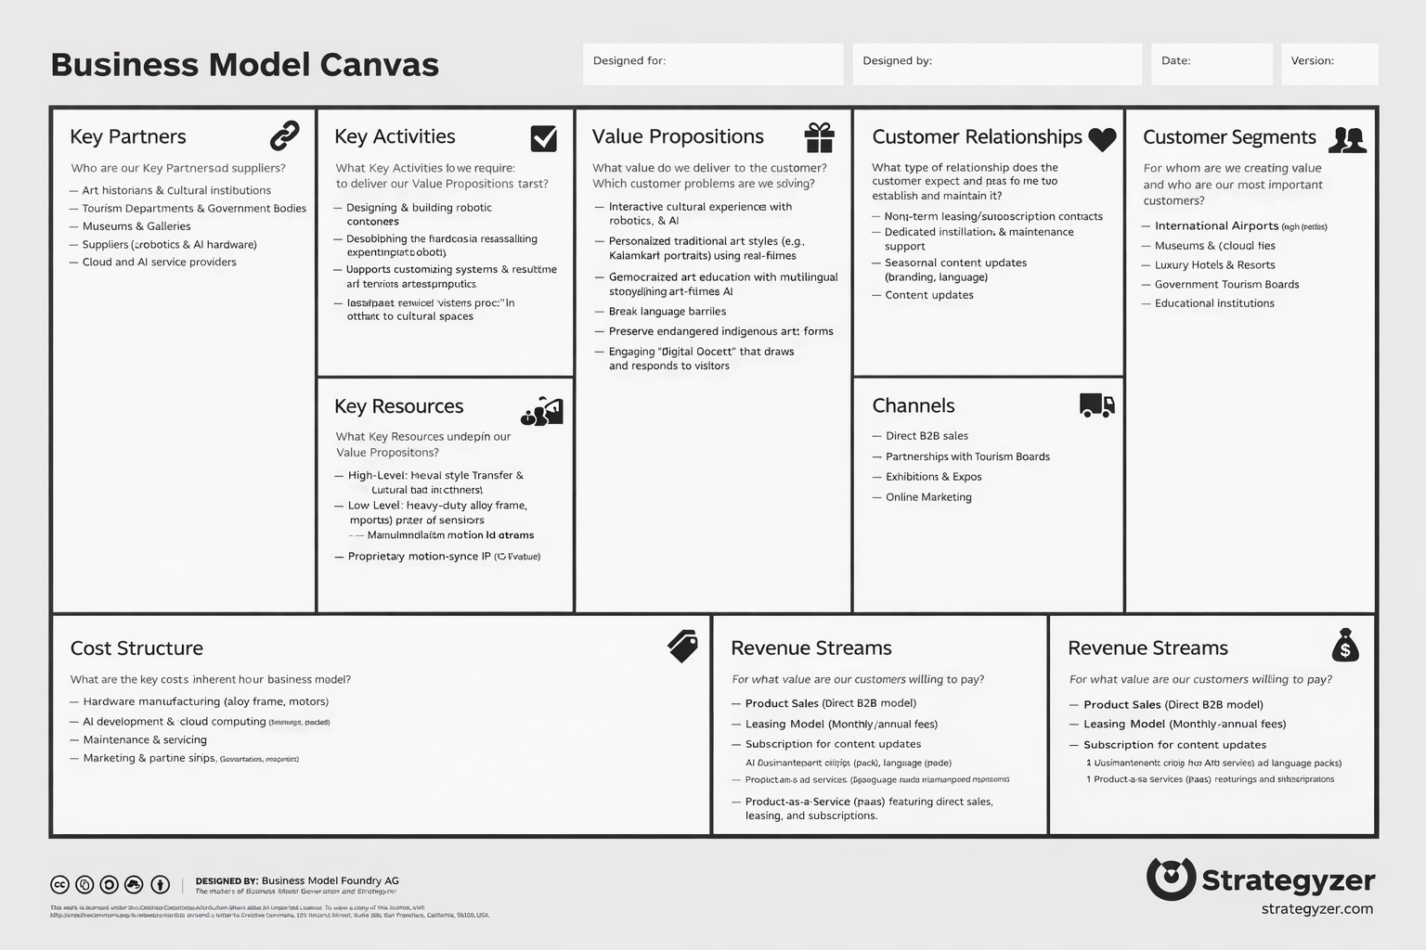
- Strategic Partners: Key collaborations include Cultural Institutions for user testing, Hardware Manufacturers for a reliable supply chain of precision components, and Government/NGOs to secure the data and funding needed for heritage preservation.

Sources
- Gatys, L. A., Ecker, A. S., & Bethge, M. (2015). "A Neural Algorithm of Artistic Style." * Why: This is the foundational paper for Neural Style Transfer. It explains how AI separates "content" from "style."
- Simonyan, K., & Zisserman, A. (2014). "Very Deep Convolutional Networks for Large-Scale Image Recognition." * Why: This introduces the VGG-19 network, the specific AI architecture used to "understand" artistic features.
- Huang, H., et al. (2017). "Real-Time Neural Style Transfer for Videos." * Why: A key source for making the AI work instantly (real-time) rather than taking minutes to process one image.
- S-Curve Trajectory Planning Research (e.g., MDPI Robotics). "S-Curve Trajectory Planning for Industrial Robots Based on Curvature Radius." * Why: Explains the math behind making the robot move smoothly and "organically" like a human, rather than with jerky mechanical motions.
- Human-Robot Interaction (HRI) Studies. * Why: Search for articles on "Robotic Eye Contact" or "Social Robotics in Museums" to justify why the robot turns to face the visitor.
- The Chitrolekha Journal on Art and Design. "Kalamkari, the Art of Painting with Natural Dyes." Why: Provides the history of Kalamkari, from its origins in temples to its use as a storytelling medium.
- Google Arts & Culture (Website). artsandculture.google.com Why: A major reference for how AI is currently being used to digitise and preserve global heritage (see their "AI + Heritage" experiments).
- UNESCO Charter on the Preservation of Digital Heritage. Why: This is a vital "policy" source that proves why your project is important for saving "at-risk" cultural data.
- Pine, B. J., & Gilmore, J. H. "The Experience Economy." (Book/Article) Why: This explains the business theory that people today value "memorable experiences" over simple products—proving there is a market for your robot.
- Bhashini Initiative (Website). bhashini.gov.in Why: An example of a real-world project (in India) using AI to break language barriers, supporting your "multilingual docent" feature.

